/** Model 1 =Baseline Model **/

| **Odds Ratio Estimates and Profile-Likelihood Confidence Intervals** | | | | |  |
| --- | --- | --- | --- | --- | --- |
| **Effect** | **Unit** | **Estimate** | **95% Confidence Limits** | | **P value** |
| **age** | 5.0000 | 0.809 | 0.701 | 0.928 | 0.0029 |
| **gender Male vs Female** | 1.0000 | 1.868 | 1.119 | 3.138 | 0.0173 |
| **Nmon (ART by Month)** | 1.0000 | 0.995 | 0.983 | 1.006 | 0.3762 |
| **Prin1(Wealth Index I)** | 0.1000 | 1.007 | 0.996 | 1.019 | 0.2325 |
| **employ Unemployed vs Employed** | 1.0000 | 1.789 | 0.965 | 3.308 | 0.0636 |
| **partner Yes vs No** | 1.0000 | 1.447 | 0.859 | 2.461 | 0.1680 |
| **faith_act Not Active/No Religion vs Active** | 1.0000 | 1.684 | 1.059 | 2.685 | 0.0278 |
| **family_HIV_bin none vs 1-4** | 1.0000 | 0.608 | 0.377 | 0.977 | 0.0404 |
| **treat_support Yes vs No** | 1.0000 | 2.003 | 1.096 | 3.668 | 0.0237 |
| **rhiv Who first recommended you to go to an HIV clinic? (Friend vs Family)** | 1.0000 | 0.384 | 0.168 | 0.840 | 0.0156 |
| **rhiv Who first recommended you to go to an HIV clinic? (Other vs Family)** | 1.0000 | 0.409 | 0.198 | 0.827 |
| **rhiv Who first recommended you to go to an HIV clinic? (Provider vs Family)** | 1.0000 | 0.842 | 0.473 | 1.504 |
| **arv_start Sinikithemba (Ridge House) vs Other** | 1.0000 | 0.489 | 0.227 | 1.057 | 0.0671 |
| **arv_train_bin 3+ vs 0-2** | 1.0000 | 0.334 | 0.109 | 0.964 | 0.0465 |
| **current_regimen Other vs D4T** | 1.0000 | 0.500 | 0.286 | 0.873 | 0.0515 |
| **current_regimen ZDV vs D4T** | 1.0000 | 0.641 | 0.306 | 1.326 |
| **CO-TRIMOXAZOLE Yes vs No** | 1.0000 | 1.677 | 0.997 | 2.831 | 0.0516 |
| **FLUCONAZOLE Yes vs No** | 1.0000 | 4.508 | 1.292 | 21.032 | 0.0288 |
| **TBD ETHAMBUTOL Yes vs No** | 1.0000 | 2.773 | 0.748 | 11.694 | 0.1365 |

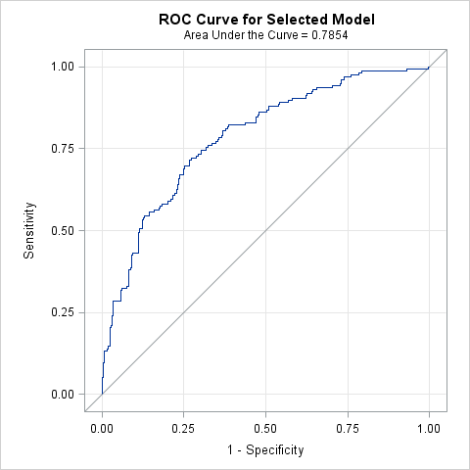

| **Hosmer and Lemeshow Goodness-of-Fit Test** | | |
| --- | --- | --- |
| **Chi-Square** | **DF** | **Pr > ChiSq** |
| 1.9345 | 8 | 0.9830 |

/** Model 2 =Demo + Socieconomic +Psycho + Symptoms + Medical History + Medications **/

/*With all suscpted variables*/

| **Odds Ratio Estimates and Profile-Likelihood Confidence Intervals** | | | | |  |
| --- | --- | --- | --- | --- | --- |
| **Effect** | **Unit** | **Estimate** | **95% Confidence Limits** | | **P value** |
| **age** | 5.0000 | 0.873 | 0.726 | 1.045 | 0.1423 |
| **gender Male vs Female** | 1.0000 | 2.037 | 1.156 | 3.619 | 0.0143 |
| **Nmon (ART by Month)** | 1.0000 | 1.005 | 0.993 | 1.017 | 0.4338 |
| **edu** | 1.0000 | 1.143 | 0.991 | 1.334 | 0.0762 |
| **partner Yes vs No** | 1.0000 | 1.408 | 0.782 | 2.565 | 0.2573 |
| **clinic_feel Pleased vs Neutral** | 1.0000 | 0.406 | 0.223 | 0.733 | 0.0029 |
| **practice_safe_bin Often,Sometimes,Rarely,Never vs Always** | 1.0000 | 4.428 | 1.830 | 10.988 | 0.0011 |
| **dep_11 12+ vs 10 or 11** | 1.0000 | 3.604 | 2.107 | 6.336 | <.0001 |
| **faith_act Not Active/No Religion vs Active** | 1.0000 | 1.683 | 1.003 | 2.840 | 0.0492 |
| **treat_support Yes vs No** | 1.0000 | 1.609 | 0.786 | 3.269 | 0.1890 |
| **family_HIV_bin none vs 1-4** | 1.0000 | 0.652 | 0.384 | 1.104 | 0.1123 |
| **symptom_skin Patient have symptom=Yes vs No** | 1.0000 | 2.410 | 1.413 | 4.146 | 0.0013 |
| **log_cd4** | 1.0000 | 0.073 | 0.027 | 0.176 | <.0001 |
| **FLUCONAZOLE Yes vs No** | 1.0000 | 3.727 | 0.782 | 22.876 | 0.1209 |
| **current_regimen Other vs D4T** | 1.0000 | 0.393 | 0.210 | 0.727 | 0.0125 |
| **current_regimen ZDV vs D4T** | 1.0000 | 0.503 | 0.216 | 1.142 |
| **remember_meds___7(TV/Radio) Yes vs No** | 1.0000 | 3.578 | 1.557 | 8.377 | 0.0028 |
| **arv_start Sinikithemba (Ridge House) vs Other** | 1.0000 | 0.355 | 0.152 | 0.826 | 0.0161 |

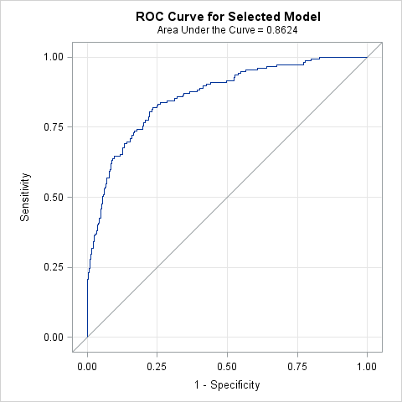

| **Hosmer and Lemeshow Goodness-of-Fit Test** | | |
| --- | --- | --- |
| **Chi-Square** | **DF** | **Pr > ChiSq** |
| 3.6788 | 8 | 0.8849 |

/** Model 3 =Demo + Socieconomic +Psycho + Accesss **/

| **Odds Ratio Estimates and Profile-Likelihood Confidence Intervals** | | | | |  |
| --- | --- | --- | --- | --- | --- |
| **Effect** | **Unit** | **Estimate** | **95% Confidence Limits** | | **P value** |
| **age** | 5.0000 | 0.860 | 0.732 | 1.008 | 0.0642 |
| **gender Male vs Female** | 1.0000 | 2.530 | 1.537 | 4.207 | 0.0003 |
| **Nmon (ART by Month)** | 1.0000 | 0.989 | 0.978 | 0.999 | 0.0295 |
| **Mpr(Access)** | 0.1000 | 0.956 | 0.790 | 1.146 | 0.6285 |
| **Edu** | 1.0000 | 1.112 | 0.985 | 1.271 | 0.0994 |
| **Prin1 (Wealth Index I)** | 0.1000 | 1.010 | 0.999 | 1.023 | 0.0898 |
| **employ Unemployed vs Employed** | 1.0000 | 1.947 | 1.059 | 3.588 | 0.0318 |
| **dep_11(Depression Score) 12+ vs 10 or 11** | 1.0000 | 3.001 | 1.846 | 4.968 | <.0001 |
| **faith_act Not Active/No Religion vs Active** | 1.0000 | 1.550 | 0.967 | 2.493 | 0.0690 |
| **family_HIV_bin none vs 1-4** | 1.0000 | 0.662 | 0.413 | 1.058 | 0.0850 |
| **practice_safe_bin Often,Sometimes,Rarely,Never vs Always** | 1.0000 | 3.224 | 1.517 | 7.050 | 0.0027 |
| **treat_support Yes vs No** | 1.0000 | 1.855 | 1.015 | 3.399 | 0.0442 |
| **clinic_feel Pleased vs Neutral** | 1.0000 | 0.376 | 0.218 | 0.643 | 0.0004 |

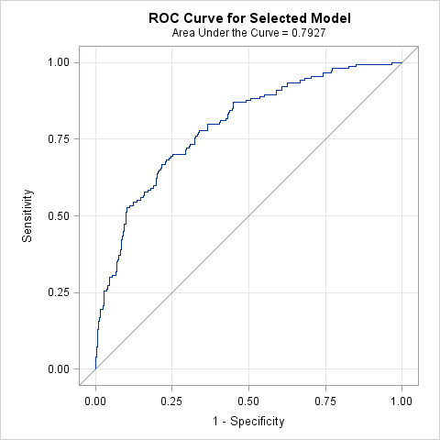

| **Hosmer and Lemeshow Goodness-of-Fit Test** | | |
| --- | --- | --- |
| **Chi-Square** | **DF** | **Pr > ChiSq** |
| 4.6130 | 8 | 0.7980 |

/** Model 4 =Demo + Psycho + Symptoms + Medical History + Medications + Adherence **/

| **Odds Ratio Estimates and Profile-Likelihood Confidence Intervals** | | | | |  |
| --- | --- | --- | --- | --- | --- |
| **Effect** | **Unit** | **Estimate** | **95% Confidence Limits** | | **P value** |
| **age** | 5.0000 | 0.805 | 0.684 | 0.940 | 0.0075 |
| **gender Male vs Female** | 1.0000 | 2.371 | 1.331 | 4.268 | 0.0036 |
| **Nmon (ART by Month)** | 1.0000 | 1.008 | 0.995 | 1.021 | 0.2289 |
| **Pill(Adherence)** | 0.1000 | 0.722 | 0.558 | 0.923 | 0.0115 |
| **dep_11(Depression Score) 12+ vs 10 or 11** | 1.0000 | 3.537 | 2.019 | 6.384 | <.0001 |
| **faith_act Not Active/No Religion vs Active** | 1.0000 | 1.664 | 0.970 | 2.872 | 0.0652 |
| **family_HIV_bin none vs 1-4** | 1.0000 | 0.569 | 0.328 | 0.979 | 0.0426 |
| **practice_safe_bin Often,Sometimes,Rarely,Never vs Always** | 1.0000 | 4.973 | 1.967 | 12.884 | 0.0008 |
| **treat_support Yes vs No** | 1.0000 | 1.527 | 0.730 | 3.154 | 0.2548 |
| **clinic_feel Pleased vs Neutral** | 1.0000 | 0.473 | 0.254 | 0.879 | 0.0177 |
| **symptom_skin Patient have symptom=Yes vs No** | 1.0000 | 2.614 | 1.493 | 4.634 | 0.0009 |
| **log_cd4** | 1.0000 | 0.066 | 0.024 | 0.166 | <.0001 |
| **arv_start Sinikithemba (Ridge House) vs Other** | 1.0000 | 0.389 | 0.160 | 0.960 | 0.0380 |
| **current_regimen Other vs D4T** | 1.0000 | 0.444 | 0.234 | 0.836 | 0.0425 |
| **current_regimen ZDV vs D4T** | 1.0000 | 0.538 | 0.227 | 1.245 |
| **remember_meds___7(TV/Radio) Yes vs No** | 1.0000 | 3.912 | 1.658 | 9.428 | 0.0020 |
| **FLUCONAZOLE Yes vs No** | 1.0000 | 3.462 | 0.641 | 23.848 | 0.1727 |

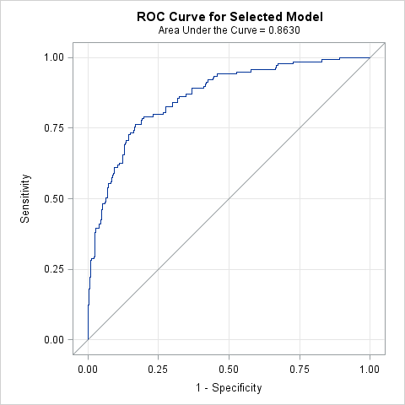

| **Hosmer and Lemeshow Goodness-of-Fit Test** | | |
| --- | --- | --- |
| **Chi-Square** | **DF** | **Pr > ChiSq** |
| 3.1870 | 8 | 0.9221 |

/** Model 5 =Demo + Socieconomic +Psycho + Symptoms + Medical History + Medications + Access + Adherence **/

/*With single-out from domain*/

| **Odds Ratio Estimates and Profile-Likelihood Confidence Intervals** | | | | |  |
| --- | --- | --- | --- | --- | --- |
| **Effect** | **Unit** | **Estimate** | **95% Confidence Limits** | | **P value** |
| **age** | 5.0000 | 0.878 | 0.726 | 1.056 | 0.1711 |
| **gender Male vs Female** | 1.0000 | 2.392 | 1.339 | 4.325 | 0.0034 |
| **Nmon (ART by Month)** | 1.0000 | 1.007 | 0.994 | 1.020 | 0.2789 |
| **Pill (Adherence)** | 0.1000 | 0.730 | 0.565 | 0.930 | 0.0137 |
| **edu** | 1.0000 | 1.139 | 0.983 | 1.334 | 0.0945 |
| **dep_11(Depression Score) 12+ vs 10 or 11** | 1.0000 | 3.666 | 2.084 | 6.644 | <.0001 |
| **faith_act Not Active/No Religion vs Active** | 1.0000 | 1.715 | 0.996 | 2.973 | 0.0526 |
| **family_HIV_bin none vs 1-4** | 1.0000 | 0.575 | 0.331 | 0.992 | 0.0476 |
| **practice_safe_bin Often,Sometimes,Rarely,Never vs Always** | 1.0000 | 4.760 | 1.886 | 12.329 | 0.0011 |
| **treat_support Yes vs No** | 1.0000 | 1.522 | 0.727 | 3.147 | 0.2592 |
| **clinic_feel Pleased vs Neutral** | 1.0000 | 0.456 | 0.244 | 0.849 | 0.0132 |
| **symptom_skin Patient have symptom=Yes vs No** | 1.0000 | 2.645 | 1.506 | 4.703 | 0.0008 |
| **log_cd4** | 1.0000 | 0.064 | 0.023 | 0.161 | <.0001 |
| **arv_start Sinikithemba (Ridge House) vs Other** | 1.0000 | 0.447 | 0.183 | 1.107 | 0.0785 |
| **current_regimen Other vs D4T** | 1.0000 | 0.415 | 0.216 | 0.790 | 0.0285 |
| **current_regimen ZDV vs D4T** | 1.0000 | 0.539 | 0.226 | 1.257 |
| **remember_meds___7(TV/Radio) Yes vs No** | 1.0000 | 4.047 | 1.717 | 9.741 | 0.0015 |
| **FLUCONAZOLE Yes vs No** | 1.0000 | 3.529 | 0.643 | 24.014 | 0.1664 |

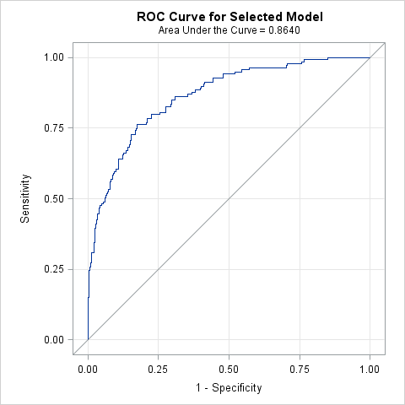

| **Hosmer and Lemeshow Goodness-of-Fit Test** | | |
| --- | --- | --- |
| **Chi-Square** | **DF** | **Pr > ChiSq** |
| 2.4599 | 8 | 0.9636 |